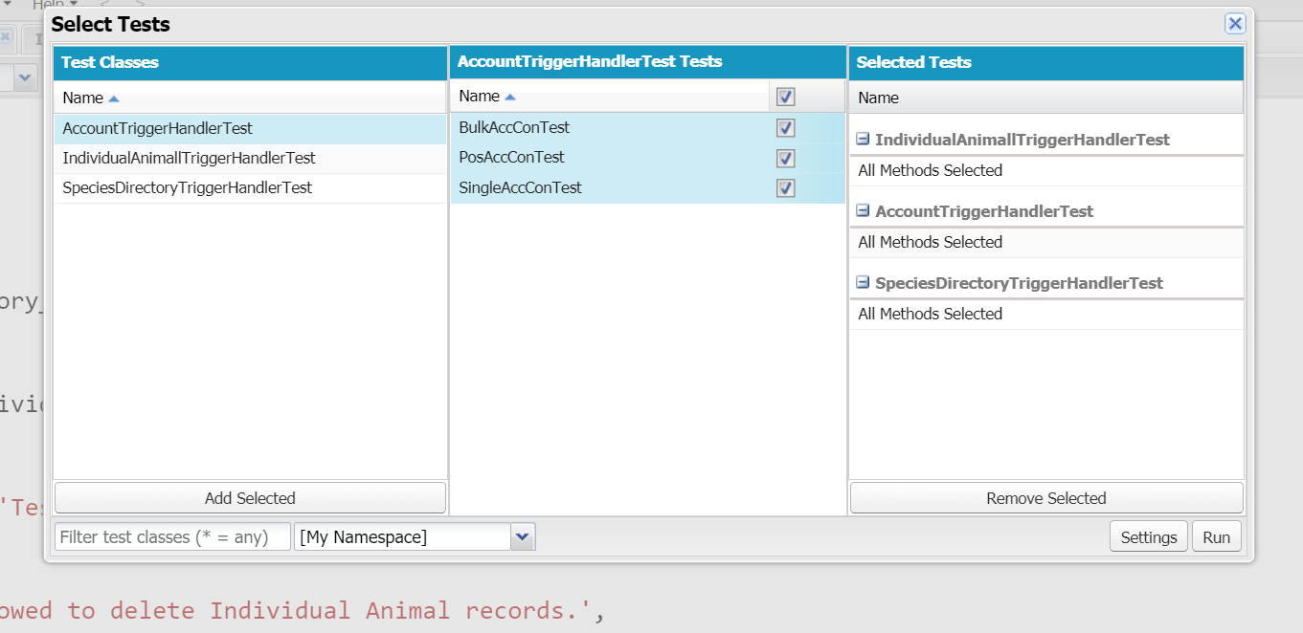

Note that it says “All Methods Selected” for each test. This is showing you that I have multiple tests in each Test Class (not just one test qualifying as “All” tests)

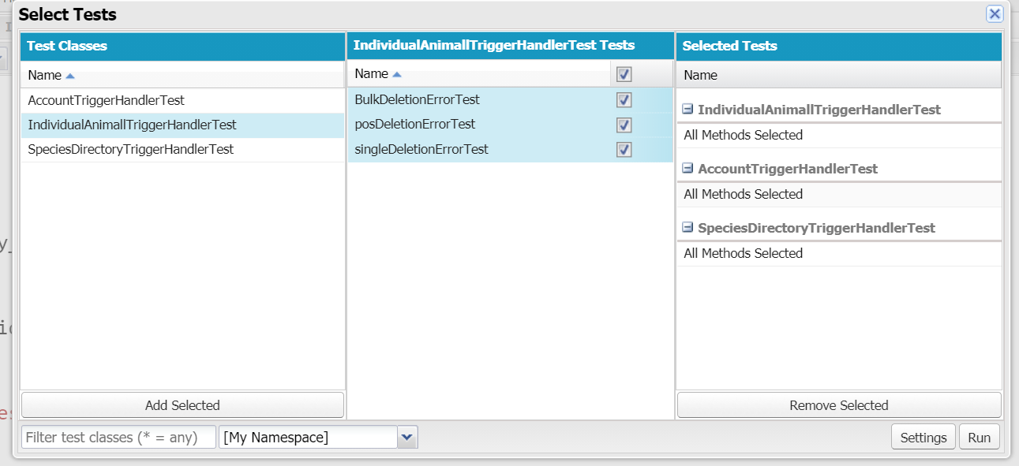

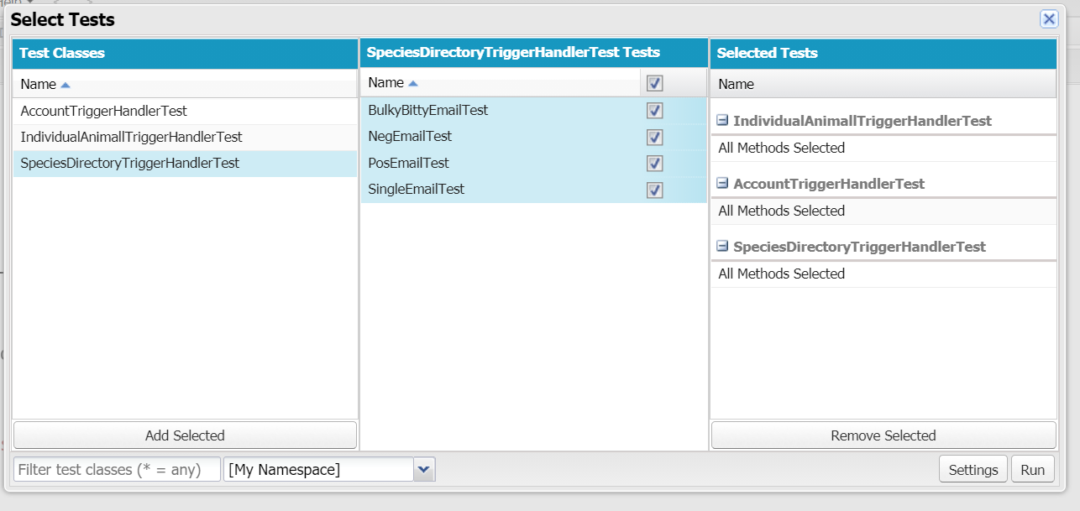

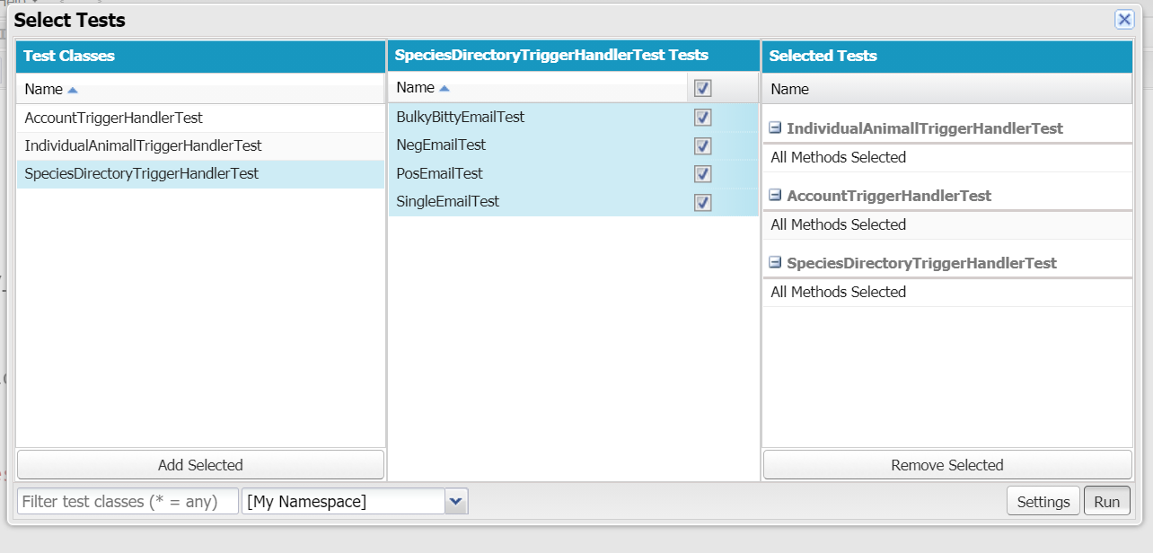

Note that, in the image above, the “Run” button is depressed—not sad, but pressed down.

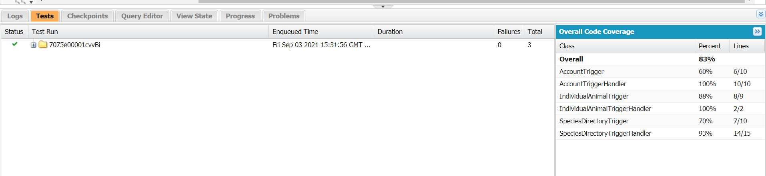

Note that “Overall” is including Triggers, and is ∴ (∴ means “therefore”) not the code-coverage percentage.

* Code Coverage Math (as seen below)

100 + 100 + 93 = 293

293 / 3 = 97.66666666666666666666666666666666667

98%, b/c I believe in rounding up

Which is braggable

Brag-worthy

Ok, thx <3

* Trigger Coverage Math (even tho u didn’t want, I am extra – if u hadn’t noticed yet)

60 + 88 + 70 = 218

218 / 3 = 72.66666666666666666666666666666666667

73%, if we round up

(which is 72% more than required)

Ur welcome <3